Scheme Advisory Board Annual Review

Chair’s Introduction and reflection over the last 12 months
This is the first Scheme Advisory Board Annual review to be published, and I am delighted to be able to share this with you. This review has two aims; the first is to share the key work undertaken by the Board, its committees and working groups in one succinct, factual-based overview of the previous 12 months, along with a high-level breakdown of how the budget for the previous year has been spent. The second is to highlight the various workstreams that the Board and the Secretariat have planned for the coming 12 months so the Fire community can engage with and have awareness of the work planned.

I am pleased to have been reappointed in the role of Chair of the Scheme Advisory Board by the Ministry of Housing, Communities & Local Government (MHCLG). I look forward to being able to being to continue to work on the many challenges that have been evident from the last 12 months such as ensuring that the data is available to finalise the Matthews and McCloud remedies and required for the Dashboard.

Joanne Livingstone, Scheme Advisory Board Chair

Firefighters’ Pension Scheme (England) Scheme Advisory Board
The Firefighters’ Pension Scheme (FPS) is a national public service pension scheme that is locally administered with 33,422 members, and 44 individual scheme managers across England.

The Scheme Advisory Board (the Board) was introduced by the Public Service Pension Act 2013 and Firefighters’ Pension Scheme (Governance) Regulations 2014.

The Board has two main functions:

- provide advice as requested by the Secretary of State on the desirability of making changes to the scheme
- provide advice to the Scheme Managers and Local Pension Boards in relation to the effective and efficient administration and management of the scheme

The Board also have three sub committees that support objectives on cost, administration, and Local Pension Board (LPB) effectiveness.

Overview of the last twelve months (May 2024 to June 2025)
The last twelve months have seen a huge amount of work carried out within the fire pensions sector. An overview of the work that the Board has carried out is detailed below:

Meetings and Governance

- Further details on the meetings of the Board are given later in this Review.
- Review of own governance arrangements including updating Terms of Reference, adopting new Business Plan and initial work on a communications plan.

Guidance

- Legal opinion with regards to draft Matthews legislation
- Actuarial and legal oversight including attendance at the SAB meetings
- Communications projects - RSS templates and new member website.

Working with government and policy development

- Migration to MHCLG
- Input into employee contribution rates review
- Early work in connection with the 2024 Fire actuarial valuation
- Initial review of survey fundings and development of a SAB view on the Need for Change
- Input into consultation on Inheritance Tax Changes
- Liaison with the Pensions Dashboard Program
- Liaison with the Responsible Authority regarding outstanding policy areas including with regard to Matthews and Sergeant compensation, Matthews extension and regulations .

Working with Local Pension Boards and Scheme Managers

- Attendance at training sessions for new members to explain the work of SAB
- Chairing of the annual conference
- Attendance at Local Pension Boards forums.

Remedy

- Remedy updates from main administrators and Software Providers considered at every meeting.
- Tracking of statements issued for Sargeant and Matthews communications.

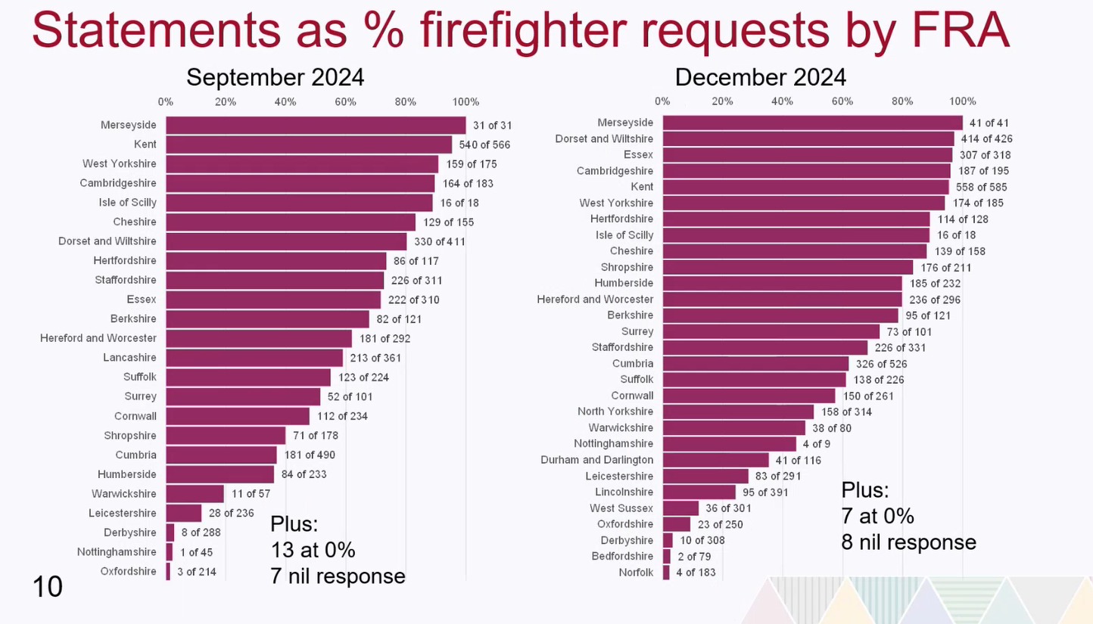

Board budget
The Board budget is set each financial year and is agreed by the fire Minister. The budget for 2024/2025 was agreed by the fire minister in November 2024 at £244,402.21, correlating to £7.42 per firefighter. FRAs were invoiced for this alongside the LGA levy in December 2024.

The anticipated budget for 2025/2026 is expected to be £282,143.76, correlating to £8.35 per active member, but is still subject to be approved by the Minister, which is anticipated in September following the summer recess.

The expenditure for 2025/2026 is higher for the following key reasons:

- The proportion of the shared costs have increased due to the approval of a Programme Support Officer role recruitment, the funding for this from 2025/2026 onwards was approved by the Fire Service Management Committee at their meeting on 11 December 2024.
- Due to the ongoing pressures of the Sargeant/McCloud and Matthews remedy there is a requirement to keep the budget for communications and projects at a significant level, as additional support may be required to assist with keeping these on track. It is noted that this is budgeted to be lower than in 2024/2025.
- Contingency has been included to be able to support FRAs in up-and-coming projects anticipated in 2025/2026.
- Due to the forthcoming changes to the member contribution rates and bandings and 2024 valuation assumptions the actuarial budget has been kept relatively high as the Board will be utilising their services to support MHCLG and GAD with the final policy position.
- A substantial increase in the website development/maintenance budget amount is due to the necessary work, to develop a new FPS member website and ensure that it receives an accessibility accreditation.

Risk Management
The Board actively manages a risk register as a key strategic and operational tool which drives focus on priority issues within Board meetings and day to day activity of the Board secretariat.

The full risk register can be found on the FPS Board website. This identifies key risks and considers and assesses the significance, likelihood of occurrence and potential impact of the risk. Where possible, measures are put in place to manage or mitigate the risk or provide transparency where the risk is to be tolerated. The approach to mitigation and details of the actions taken are included in the full risk register.

The Board reviews the risk register every other meeting, and the secretariat will consider changes between formal meetings, escalating where appropriate.

Key themes from the risk register are highlighted below:

- Problems arising from resource constraints within the industry
- Risks arising from complexity and fragmentation of the arrangements
- Historic issues around data and retrospective changes.

Governance
In 2025, the Board formalised its governance arrangements allowing for better oversight of all areas of governance i.e. membership, attendance, Board policy documents, meeting dates and format.

Board Membership and Attendance

Membership

The Board is required to consist of a chair and at least two, but no more than fourteen persons appointed by the Secretary of State.
The Firefighters’ Pension (England) Scheme Advisory Board is made up of:
  - Seven employer representatives
    - These seven places have been selected by the Firefighters’ Pension Team of the Local Government Association with input from the Chair and Fire Services Management Committee (FSMC)
  - Seven member representatives
    - These seven places are split between the four trade unions based on four seats for the Fire Brigades Union (FBU) and one each for the Fire and Rescue Services Association (FRSA), the Fire Officers’ Association (FOA) and the Fire Leaders Association (FLA).
The Board meets four times per year.

In the last year this has been two times in person (December and March) at the LGA offices at Smith Square, and two times (September and June) virtually.

It is proposed that going forward all meetings will be in person to encourage improved communication, stronger relationships, increased focus and productivity, and the ability to address sensitive issues effectively.

Attendance

Board attendance is recorded and published on the FPS Board website.

In the last twelve months:

  - Of the six employer representatives the average attendance was 45.83%, with no one member attending for all four meetings.
  - Of the seven member representatives the average attendance was 89.29% with four representatives attending 100% of the meetings and three attending 75% of the meetings.

Pension Board Policy documents
The Board has several policy documents which support their work, these are published on the About the Board section of the FPS Board website and are summarised below:

Terms of Reference – Defines the purpose and structure of the Board.

Code of Conduct Policy – Defines the principles that should be governed in relation to the behavior and actions of the Board.

Conflict of Interest Policy - Sets out the process to be followed where there may be a potential or actual conflict of interest for Board members.

Knowledge and Understanding Policy – Supports the development and maintenance of knowledge and understanding for Board members.

Training
In addition to attending meetings, the Board are expected to participate in training arranged in order to meet and maintain the requirements set out in the Boards knowledge and understanding policy.

On an annual basis the Board are asked to complete a Training needs analysis, to allow for the secretariat to create an electronic training log and to develop a Board training plan. The training strategy forms part of the Board business plan.

Business Plan and priority work over the coming twelve months (June 2025 to May 2026)
At their June 2025 meeting, the Board approved their business plan alongside the budget for the coming twelve months. The Board’s business plan is published on FPS Board website.
The key workplan items are as follows:

- Sargeant implementation issues
- Matthews implementation issues
- Pensions Dashboards
- 2024 valuation - assumptions and results
- Implementation of changes to employee contribution rates 2026
- Input into the Need for Change review being conducted by the LGA Firefighters’ Pensions Team.

As at 1 April 2024
The Board have been operating on a vacancy for the past twelve months

